
Submitted By:
Khadija tul kubra _ 2025-cys-68
Assignment:
Lab No. 1
Submitted To:
Shahmeer Nawaz
For the fulfillment of,
Object-Oriented Programming Lab
Department of Computer Engineering
University of engineering and technology , Lahore

Task 1:
Change the Factorial code discussed in class so that it shows proper messaging in case of negative numbers.
Solution:
import java.util.Scanner;

public class Factorial {
public static void main(String[] args) {
Scanner num= new Scanner(System.in);
System.out.print("Enter a number: ");
int n = num.nextInt();

if (n < 0) {
System.out.println("Factorial is not defined for negative numbers.");
} else {
long fact = 1;
for (int i = 1; i <= n; i++) {
fact *= i;
}
System.out.println("Factorial = " + fact);
}
}
}
Output: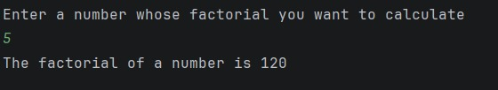
Task 2:
Change the Series_Generator such that it can generate both increasing series or decreasing series depending on the starting and ending values.
SOLUTION:
import java.util.Scanner;

public class SeriesGenerator {
public static void main(String[] args) {
Scanner sc = new Scanner(System.in);

System.out.print("Enter start value: ");
int start = sc.nextInt();

System.out.print("Enter end value: ");
int end = sc.nextInt();

if (start <= end) {
for (int i = start; i <= end; i++) {
System.out.print(i + " ");
}
} else {
for (int i = start; i >= end; i--) {
System.out.print(i + " ");
}
}
}
}
Output:
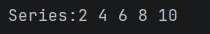
TASK 3:
Write a Program that takes year as an input from user and determine if it’s a leap year or not.
SOLUTION:
import java.util.Scanner;

public class LeapYear {
public static void main(String[] args) {
Scanner sc = new Scanner(System.in);
System.out.print("Enter Year: ");
int year = sc.nextInt();

if ((year % 4 == 0 && year % 100 != 0) || (year % 400 == 0)) {
System.out.println("It is a leap year");
} else {
System.out.println("It is not a leap year");
}
}
}
Output:
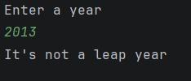
Task 4:
You are interested in calculating your electricity bill of your home. You know the unit consumption of your home. Billing criteria for electric company is that it charges 5 Rs/ unit for first 100 units, next 100 units are charged at 7 Rs/unit and above that charge is 15 Rs/unit. As input, you get total_Units consumed and generate bill.
Solution:
import java.util.Scanner;

public class ElectricityBill {
public static void main(String[] args) {
Scanner sc = new Scanner(System.in);
System.out.print("Enter Units Consumed: ");
int units = sc.nextInt();

int bill;
if (units <= 100) {
bill = units * 5;
} else if (units <= 200) {
bill = (100 * 5) + ((units - 100) * 7);
} else {
bill = (100 * 5) + (100 * 7) + ((units - 200) * 15);
}
System.out.println("Bill: " + bill)
}
}
Output:
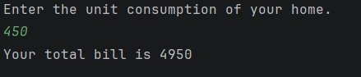
Task 5:
Write a program that takes an integer n from command-line arguments and uses a while loop to compute the number of times you need to divide n by 2 until it is strictly less than 1. Print the error message “Illegal input” if n is negative.
Solution:
public class DivideByTwo {
public static void main(String[] args) {
if (args.length == 0) {
System.out.println("Please enter a number.");
return;
}
int n = Integer.parseInt(args[0]);
if (n < 0) {
System.out.println("Illegal input");
return;
}
int count = 0;
while (n >= 1) {
n = n / 2;
count++;
}
System.out.println("Number of divisions: " + count);
}
}
Output:
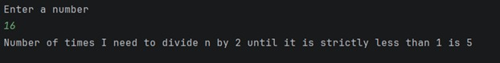
Task 6:
Write a code that takes a number value from user and displays the inverse of it. Number can be of any length.
Solution:
import java.util.Scanner;

public class ReverseNumber {
public static void main(String[] args) {
Scanner sc = new Scanner(System.in);
System.out.print("Enter Number: ");
int num = sc.nextInt();
int reverse = 0;
while (num != 0) {
int digit = num % 10;
reverse = reverse * 10 + digit;
num /= 10;
}
System.out.println("Inverse: " + reverse);
}
}
Output: 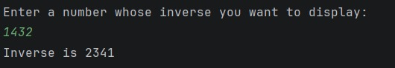
Assignment:
Lab No. 2
For the fulfillment of,
Object-Oriented Programming Lab
Department of Computer Engineering
University of Engineering and Technology, Lahore

TASK NO 1:
The Geometry Calculator (Operators & Math)
- Create a program that stores the radius of a circle as a double.
- Calculate the area ($Area = \pi \times r^2$). Use Math.PI and Math.pow().
- Print the result. Then, use Type Casting to print the area as a whole integer.
Solution:
import java.util.Scanner;
public class Calculator
{
public static void main(String[] args)
{
Scanner sc = new Scanner(System.in);
System.out.print("Enter the radius of the circle: ");
double radius = sc.nextDouble();
double area = Math.PI * Math.pow(radius,2);
System.out.println("Area is "+area);
int Area =(int) area;
System.out.println("The area in whole integer is " +Area);
}
}
Output:
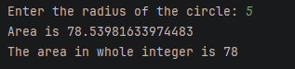
TASK NO 2:
String Analysis Tool (Strings)
- • Create a String variable fullName containing your first and last name.
- • Print the length of the string.
- • Convert the name to all uppercase.
- • Use indexOf() to find the position of the space between the names
Solution:
public class String_Tool
{
public static void main(String[] args)
{
java.lang.String fullName = "Eshail Fatima";
System.out.println(fullName.length());
System.out.println(fullName.toUpperCase());
System.out.println(fullName.indexOf(" "));
}
}
Output:
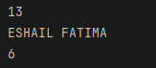
TASK NO 3:
Automatic Grade Converter (Type Casting)
- Declare a double variable percentage = 85.99.
- Manually cast this percentage into an int.
- Print: "Your raw score is: 85.99% but your rounded grade is: 85%".
Solution:
public class Converter
{
public static void main(String[] args)
{
double percent = 85.99d;
int percentage = (int) percent;
System.out.println("Your raw score is: "+ percent + "% but your rounded grade is: "+percentage+"%.");
}
}
Output:
TASK NO 4:
The Logical Gatekeeper (Logical Operators)
- Create two boolean variables: hasID and isOver18.
- Write an if statement that prints "Access Granted" only if both are true.
- Write another statement that prints "Special Guest" if they have an ID OR they are over 18.
Solution:
import java.util.Scanner;
public class Gatekeeper
{
public static void main(String[] args)
{
Scanner input = new Scanner(System.in);
System.out.print("Do you have an id? (True/ False) ");
boolean hasID = input.nextBoolean();
Scanner input2 = new Scanner(System.in);
System.out.print("What is your age? ");
int age = input.nextInt();
boolean isOver18 = age >= 18;
if(hasID && isOver18)
{
System.out.println("Access Granted.");
}
else if (hasID || isOver18)
{
System.out.println("Special Guest.");
}
else
{
System.out.println("Access Denied. ");
}
}
}
Output:
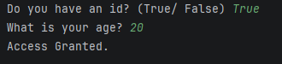
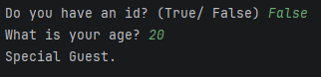
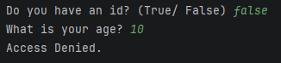
TASK NO 5:
Random Number Matcher (Math & Booleans)
- Generate a random number between 1 and 10. Hint: Use (int)(Math.random() * 11).
- Declare a variable userGuess = 5.
- Print true if the random number matches the guess, otherwise print false.
Solution:
public class Random
{
public static void main(String[] args)
{
int random = (int)(Math.random()*11);
System.out.println(random);
int userGuess = 5;
if (random == userGuess)
{
System.out.println("Ture");
}
else
{
System.out.println("False");
}
}
}
Output:
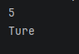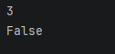
TASK NO 6:
Personalized Greeting (Strings & Concatenation)
- Create variables for greeting, firstName, and lastName.
- Use the + operator to join them for one output.
- Use the .concat() method to join them for a second output.
Solution:
public class Greeting
{
public static void main(String[] args)
{
String firstName = "Eshail";
String lastName = "Fatima";
System.out.println("Output one = "+ (firstName+lastName));
System.out.println("Output two = "+ (firstName.concat(lastName)));
}
}
Output:
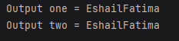
TASK NO 7:
Time-of-Day Identifier (If...Else If)
- Store an int variable hour (0 to 23).
- If hour is between 5 and 11, print "Good Morning".
- Else if hour is between 12 and 17, print "Good Afternoon".
- Else if hour is between 18 and 23, print "Good Evening".
- Use else to handle any other numbers as "Invalid Hour".
Solution:
import java.util.Scanner;
public class Identifier
{
public static void main(String[] args)
{
// Scanner sc = new Scanner(System.in);
// System.out.print("Enter hour: ");
// int hour = sc.nextInt();
int hour = 10;
if (hour >= 5 && hour<=11)
{
System.out.println("GOOD MORNING");
}
else if (hour >= 12 && hour<=17)
{
System.out.println("GOOD AFTERNOON");
}
else if (hour >= 18 && hour<=23)
{
System.out.println("GOOD EVENING");
}
else
{
System.out.println("INVALID HOUR.");
}
}
}
Output:
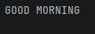
TASK NO 8:
The Currency Switcher (Switch Case)
- Create a variable String currency = "USD".
- Use a switch statement to print the full name of the currency:
  - "USD" -> "United States Dollar"
  - "GBP" -> "British Pound"
  - "EUR" -> "Euro"
  - Default -> "Unknown Currency"
Solution:
public class Currency
{
public static void main(String[] args)
{
String currency = "USD";
switch (currency)
{
case "USD":
System.out.println("United States Dollar");
break;
case "GBP":
System.out.println("British Pound");
break;
case "EUR":
System.out.println("Euro");
break;
default:
System.out.println("Unknown Currency");
}
}
}
Output:
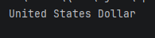
TASK NO 9:
Comparison & Increment Lab (Operators)
- Declare int x = 10 and int y = 20.
- Use a comparison operator to print if x is not equal to y.
- Apply the increment operator ++ to x.
- Print the new value of x and check if it is now greater than 10.
Solution:
public class Comparison
{
public static void main(String[] args)
{
int x = 10;
int y = 20;
if (x != y)
{
System.out.println("X is NOT equal to Y.");
}
else
{
System.out.println("X is equal to Y.");
}
x++;
System.out.println("The new vale of X is : "+x);
if(x>10)
{
System.out.println("X is greater than 10.");
}
else
{
System.out.println("X is not greater than 10.");
}
}
}
Output:
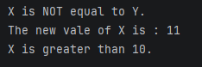

Assignment:
Lab No. 3
For the fulfillment of,
Object-Oriented Programming Lab
Department of Computer Engineering
University of Engineering and Technology, Lahore

TASK1:
Modify the Point class as discussed in class: that can represent 3-D point. Modify all the existing functions such that they work for 3-D point as well.
SOLUTION:
static class point{
private int x;
private int y;
private int z;
public point(int x,int y,int z){
this.x=x;
this.y=y;
this.z=z;
}
public void setX(int x)
{
this.x = x;
}
public void setY(int y)
{
this.y = y;
}
public void setZ(int z)
{
this.z = z;
}
public int getX()
{
return x;
}
public int getY()
{
return y;
}
public int getZ()
{
return z;
}
public void displaypoint()
{
System.out.println("Point coordinates are"+"("+x+(",")+y+(",")+z+")");
}
}
public static void main(String[]args)
{
point p= new point(2,4,6);
p.displaypoint();
}
Output:
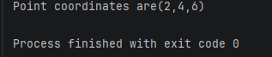
TASK2:
Think of Time as an entity. Think of attributes and functions. Implement getter setters for its attributes. And write a function whatTime ( int no_of_seconds_till_noon) and sets its attributes accordingly.
SOLUTION:
class Time{
private int hours;
private int minutes;
private int seconds;
public int getHours() {
return hours;
}
public int getMinutes() {
return minutes;
}
public int getSeconds() {
return seconds;
}
public void setHours(int hours) {
this.hours = hours;
}
public void setMinutes(int minutes) {
this.minutes = minutes;
}
public void setSeconds(int seconds) {
this.seconds = seconds;
}
public void time(int no_of_seconds_till_noon){
int totalseconds=12*3600-no_of_seconds_till_noon;
hours=totalseconds/3600;
minutes=(totalseconds%3600)/60;
seconds=totalseconds%60;
}
public void displayTime(){
System.out.println(hours+":"+minutes+":"+seconds);
}
public static void main(String[]args) {
Time t=new Time();
t.time(5600);
t.displayTime();
}
}
OUTPUT:
TASK3:
Write a program to calculate how many months it will take you to save up enough money for a down payment.
SOLUTION:
import java.util.Scanner;
public class Savings {
public static void main(String[] args) {
Scanner input = new Scanner(System.in);
System.out.println("enter your monthly salary:");
Float monthly_salary = input.nextFloat();
System.out.println("enter the amount of salary to save(in decimal):");
Float portion_saved = input.nextFloat();
System.out.println("enter cost of your dream house:");
Float total_cost = input.nextFloat();
Float portion_down_payment = 0.25f * total_cost;
Float current_saving = 0f;
Float r = 0.04f;
int months = 0;
while (current_saving < portion_down_payment) {
current_saving = current_saving + (current_saving * r / 12);
current_saving = current_saving + (portion_saved * monthly_salary);
months++;
}
System.out.println("number of months:" + months);
}
}
Output:
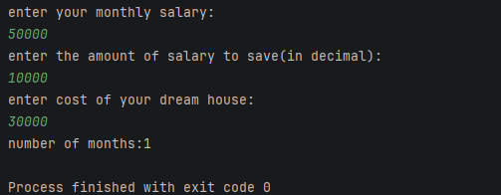

Assignment:
Lab No. 4
For the fulfillment of,
Object-Oriented Programming Lab
Department of Computer Engineering
University of Engineering and Technology, Lahore

TASK NO 1

SOLUTION:

public class JTime
{
private int hour;
private int minute;
private int second;
public JTime()
{
this.hour = 0;
this.minute = 0;
this.second = 0;
}
public JTime(int hour, int minute, int second)
{
this.hour = hour;
this.minute = minute;
this.second = second;
}
public JTime(int totalSecond)
{
this.hour = totalSecond / 3600;
totalSecond = totalSecond % 3600;
this.minute = totalSecond / 60;
this.second = totalSecond % 60;
}
public int toSeconds()
{
return (hour * 3600 + minute * 60 + second);
}
public int time_elapsed(JTime t)
{
return Math.abs(this.toSeconds() - t.toSeconds());
}
public JTime difference(JTime t)
{
int diff = Math.abs(this.toSeconds() - t.toSeconds());
return new JTime(diff);
}
public void display()
{
System.out.printf("%02d:%02d:%02d\n", hour, minute, second);
}
}
public static void main(String[] args)
{
JTime t1 = new JTime(10,20,30);
JTime t2 = new JTime(12, 37, 25);
System.out.print("Time 1 = ");
t1.display();
System.out.print("Time 2 = ");
t2.display();
System.out.println("Time difference = " + t1.time_elapsed(t2));
JTime diff = t1.difference(t2);
System.out.print("Time difference = " );
diff.display();
JTime t3 = new JTime(10000);
System.out.print("Time from 10000 seconds is ");
t3.display();
}

OUTPUT:
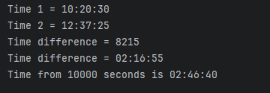

TASK NO 2

SOLUTION:

public class SavingAccount
{
private double balance;
public SavingAccount(double initial_balance)
{
this.balance = initial_balance;
}
public void deposit(double amount) {
if (amount > 0)
{
balance += amount;
System.out.println("Deposited " + amount);
} else
{
System.out.println("Invalid amount.");
}
}
public void withdraw(double amount)
{
if(amount > 0 && amount <= balance)
{
balance -= amount;
System.out.println("Withdrawn " + amount);
}
else
{
System.out.println("Invalid amount.");
}
}
public void display()
{
System.out.println("Current Balance : $" + balance);
}
}
import java.util.Scanner;
public class Main
{
public static void main(String[] args)
{
Scanner sc = new Scanner(System.in);
System.out.println("Enter your current balance: ");
double initial_balance = sc.nextDouble();
SavingAccount myAccount = new SavingAccount(initial_balance);
int options;
do
{
System.out.println("1. Deposit");
System.out.println("2. Withdraw");
System.out.println("3. Check Balance");
System.out.println("4. Exit");
System.out.print("Enter your choice: ");
options = sc.nextInt();
switch (options) {
case 1:
System.out.println("Enter the amount you want to deposit: ");
double depositAmount = sc.nextDouble();
myAccount.deposit(depositAmount);
break;
case 2:
System.out.println("Enter the amount you want to withdraw: ");
double withdrawAmount = sc.nextDouble();
myAccount.withdraw(withdrawAmount);
break;
case 3:
myAccount.display();
break;
case 4:
System.out.println("THANKS!!!");
break;
default:
System.out.println("Invalid Choice.");
}
}
while (options != 4);
}
}

OUTPUT:
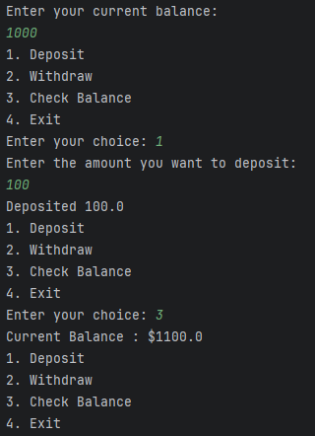

TASK NO 3

SOLUTION:

public class Walker
{
private int x , y;
private String name;
public Walker(String name)
{
this.name = name;
this.x = 0;
this.y = 0;
}
public boolean move(int nextX, int nextY, int hurdleX, int hurdleY)
{
if(nextX == hurdleX && nextY == hurdleY)
{
System.out.println(name + " encountered a hurdle at ("+ hurdleX + ":" + hurdleY + ")");
return false;
}
this.x = nextX;
this.y = nextY;
return true;
}
public String location()
{
return "(" + x + "," + y + ")";
}
public int getX() {
return x;
}
public int getY() {
return y;
}

MAIN

import java.util.Random;
import java.util.Scanner;
public class Main
{
public static void main(String[] args)
{
Scanner sc = new Scanner(System.in);
Random random = new Random();
Walker ali = new Walker("Ali");
Walker hasan = new Walker("Hasan");
int hurdleX = 1, hurdleY = 2;
System.out.println("Starting: Ali's Location is = " + ali.location() + " Hasan's Location is = " + hasan.location());
while (true) {
System.out.print("ALi: Where should i go now (^, v, <, > or 'q' to quit): ");
char move = sc.next().charAt(0);
if (move == 'q') break;
int nextAliX = ali.getX(), nextAliY = ali.getY();
if (move == '^') nextAliY++;
else if (move == 'v') nextAliY--;
else if (move == '<') nextAliX--;
else if (move == '>') nextAliX++;
ali.move(nextAliX, nextAliY, hurdleX, hurdleY);
int randomMove = random.nextInt(4);
int nextHasanX = hasan.getX();
int nextHasanY = hasan.getY();
if (randomMove == 0) nextHasanY++;
else if (randomMove == 1) nextHasanY--;
else if (randomMove == 2) nextHasanX--;
else if (randomMove == 3) nextHasanX++;
hasan.move(nextHasanX, nextHasanY, hurdleX, hurdleY);
System.out.println("Ali is at = " + ali.location());
System.out.println("Hasan is at = " + hasan.location());
System.out.println();
}
}
}

//class dayType {
// private String[] days = {"Sun", "Mon", "Tue", "Wed", "Thu", "Fri", "Sat"};
// private int currentDay; // index (0 = Sun, ..., 6 = Sat)
//
// // Default constructor (Sunday)
// public dayType() {
// currentDay = 0;
// }
//
// // Constructor with parameter
// public dayType(String day) {
// setDay(day);
// }
//
// // a. Set the day
// public void setDay(String day) {
// for (int i = 0; i < 7; i++) {
// if (days[i].equals(day)) {
// currentDay = i;
// return;
// }
// }
// System.out.println("Invalid day! Setting to Sunday.");
// currentDay = 0;
// }
// // b. Print the day
// public void printDay() {
// System.out.println(days[currentDay]);
// }
//
// // c. Return the day
// public String getDay() {
// return days[currentDay];
// }
//
// // d. Return the next day
// public String nextDay() {
// return days[(currentDay + 1) % 7];
// }
//
// // e. Return the previous day
// public String prevDay() {
// return days[(currentDay + 6) % 7];
// }
//
// // f. Add certain days and return new day
// public String addDays(int n) {
// return days[(currentDay + n) % 7];
// }
//}

OUTPUT:

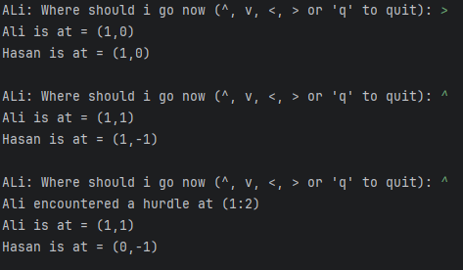

Assignment:
Lab 5
For the Fulfillment of ;

Object Oriented Programming lab Computer Engineering Department
University of Engineering and Technology, Lahore.

Lab no 5 Tasks:
Task no 1:
Design and implement a class dayType that implements the day of the week in a program. The class dayType should store the day, such as Sun for Sunday. The program should be able to perform the following operations on an object of type dayType
- Set the day.
- Print the day.
- Return the day.
- Return the next day.
- Return the previous day.
- Calculate and return the day by adding certain days to the current day.
Code:
public class Daytype { private String day; private static String[]
days={"Sunday","Monday","Tuesday","Wednesday","Thursday","Friday","Saturday"}; public Daytype(String day){ this.day=day;
}
public void setDay(String day) { this.day = day;
}
public void printday(){
System.out.println("it is "+day+" today");
}
public String getday(){ return day;
}
private int findposition(){ for(int i=0;i<days.length;i++){ if(days[i].equals(day)){ return i;
} }
return -1;
}
public String getnextday(){ int position =findposition(); if(position==6){ return days[0];
}else{ return days[position+1];
}
}
public String previousday(){ int position =findposition(); if(position==0){ return days[6];
}else{ return days[position-1];
}
}
public String adddays(int n){ int position=findposition(); int newposition=(position+n)%7; return days[newposition];
}
public static void main(String[] args){
Daytype currentday=new Daytype("Monday"); currentday.printday();
System.out.println(currentday.getday());
System.out.println("next day is :"+currentday.getnextday());
System.out.println("previous day is:"+currentday.previousday());
System.out.println("adding 4 days :"+currentday.adddays(4)); System.out.println("adding 7 days :"+currentday.adddays(7));
} }

Output:
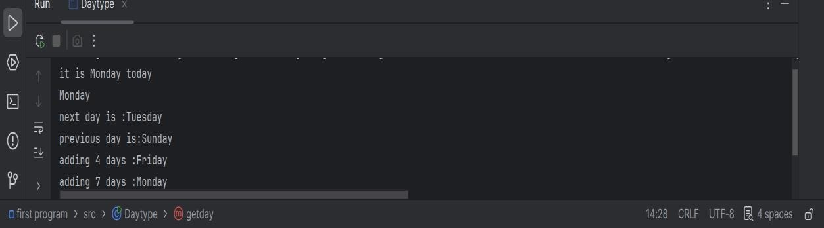

Task no 2:
2. Walls has decided that they are going to sell their ice cream in 7 different flavors namely chocolate, vanilla, strawberry, mango, tutti fruit, almond crunch, and coffee. Create a Walls class with flavor, number of scoops, cone type, and price fields. If no arguments are supplied, the flavor defaults to "Vanilla," the number of scoops defaults to 1, and the cone type defaults to "Sugar."
Code:
import java.util.Scanner;

public class Walls { String flavour; int scoops; String conetype; double price; public Walls(){ flavour="vanilla"; scoops=1; conetype="sugar"; price = calculateprice(1,"sugar");
}
public Walls(String flavour,int scoops,String conetype){ this.flavour=flavour; this.scoops=scoops; this.conetype=conetype; this.price=calculateprice(scoops,conetype);
}
public double calculateprice(int scoops,String conetype){ double total=scoops*75; if(conetype.equals("waffle")){ total=total+40;
}
return total;
}
public void printorder(){
System.out.println("\n------YOUR ORDER------");
System.out.println("flavour : "+flavour);
System.out.println("scoops :"+scoops);
System.out.println("cone type is :"+conetype);
System.out.println("Price is :"+price);
System.out.println("-------------------");
}
public static void main(String[] args){
Scanner sc=new Scanner(System.in);
System.out.println("--------Welcome to icecream shop--------"); System.out.println("choose your flavour ");
System.out.println("1 for chocolate");
System.out.println("2 for vanilla");
System.out.println("3 for strawberry");
System.out.println("4 for mango");
System.out.println("5 for tutti fruit");
System.out.println("6 for almond crunch");
System.out.println("7 for coffee");
System.out.println("enter your choice from 1 to 7 : "); int flavourchoice=sc.nextInt(); String flavour; switch(flavourchoice){ case 1: flavour="chocolate"; break; case 2: flavour="vanilla"; break; case 3: flavour="strawberry"; break; case 4: flavour="mango"; break; case 5: flavour="tutti fruit"; break; case 6: flavour="almond crunch"; break; case 7: flavour="coffee"; break; default:
flavour="vanilla";
System.out.println("INVALID CHOICE DEFAULTING TO VANILLA");
}
System.out.println("\n---cone type---");
System.out.println("1 for sugar cone");
System.out.println("2 for waffle cone with extra 40 rs charges"); System.out.println("enter your choice 1 or 2 : "); int conechoice=sc.nextInt(); String conetype; switch(conechoice){ case 1: conetype="sugar"; break;
case 2: conetype="waffle"; break; default:
conetype="sugar";
System.out.println("invalid choice so defaulting to sugar");
}
System.out.println("\n---no of scoops---");
System.out.println("1 for one scoop for rs 75");
System.out.println("2 for two scoops ");
System.out.println("3 for three scoops"); System.out.print("Enter your choice from 1 to 3 : ");

int scoopChoice=sc.nextInt(); int scoops;

switch(scoopChoice) { case 1: scoops = 1; break; case 2: scoops = 2; break; case 3: scoops = 3; break; default:
scoops = 1;
System.out.println("Invalid choice! Defaulting to 1 scoop."); break;
}
Walls myorder = new Walls(flavour, scoops, conetype); myorder.printorder(); sc.close();

} }

Output:
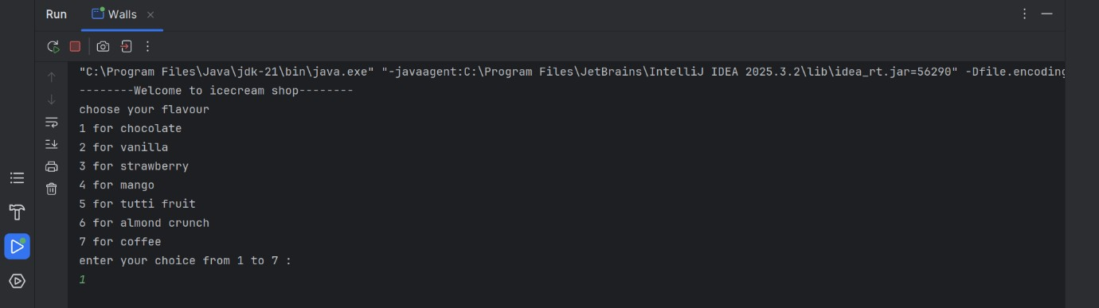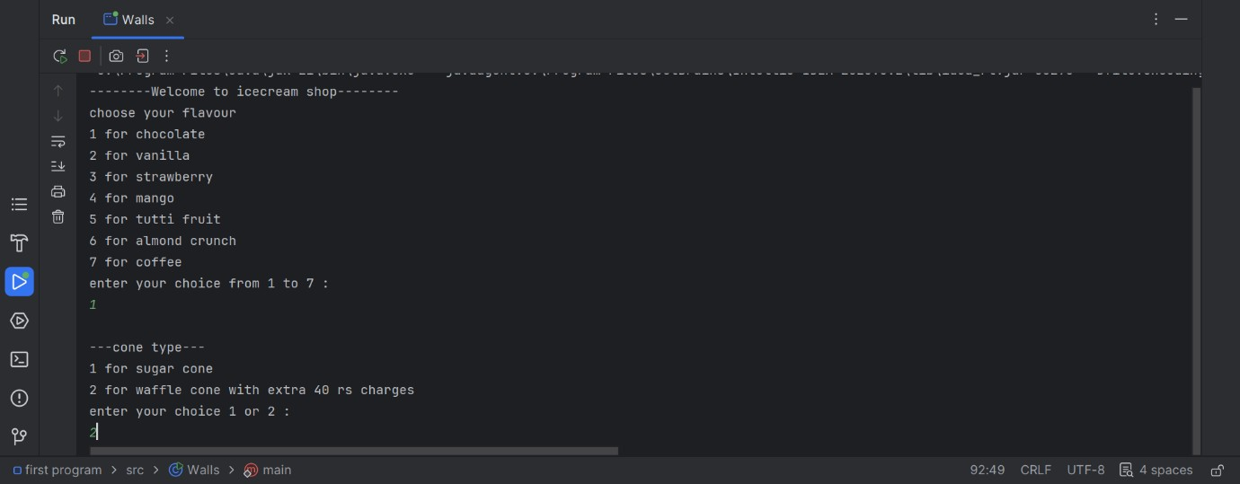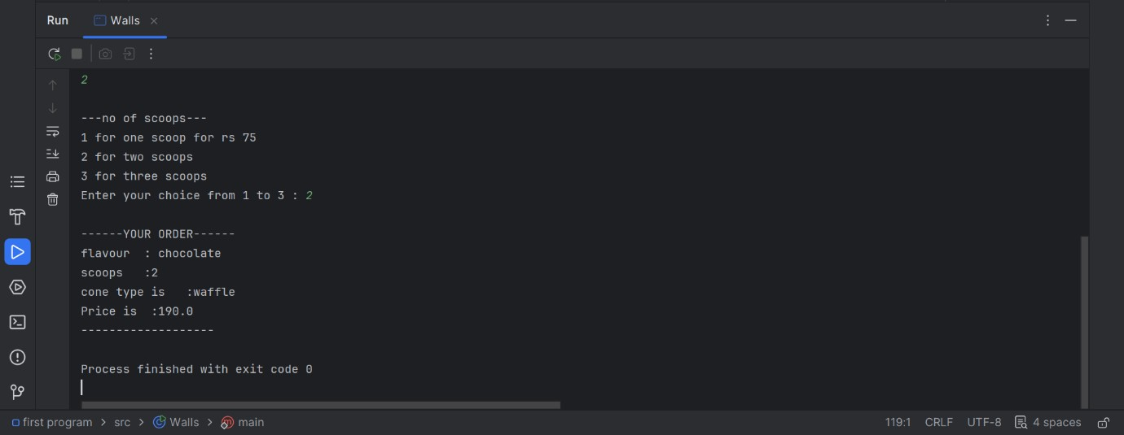

Task no 3:
3. Create a class by the named Product. Create the following private members name(String), price(int) and quantity(int). • Define a parameter-less and a parameterized constructor. • Define the following member functions. • void getData()
• static void counter() • static int countProduct() • The class would contain a static int ‘totalProduct’, having initial value equal to zero. • Each time an instance of the product class is created, the ‘counter ()’ should be called. The ‘counter ()’ increments the static member by 1 value. Suppose I create 5 products, when I execute the following code it should display 5.
Code:
public class Product { private String name; private int price; private int quantity;
private static int totalproduct = 0;

public Product() { name = "unknown"; price = 0; quantity = 0; counter();
}

public Product(String name , int price, int quantity) { this.name = name; this.price = price; this.quantity = quantity; counter();
}

public void getdata() {
System.out.println("product name : " + name);
System.out.println("product price : " + price);
System.out.println("product quantity : " + quantity);
System.out.println("-----------------------");
}
private static void counter(){ totalproduct=totalproduct+1;
}
public static int countproduct(){ return totalproduct;
}
public static void main(String[] args) { Product p1 = new Product("Rice", 200, 50); Product p2 = new Product("Sugar", 150, 30);
Product p3 = new Product("Oil", 500, 20);
Product p4 = new Product("Salt", 50, 100);
Product p5 = new Product("Biscuits", 100, 75); System.out.println("-----Product list"); p1.getdata(); p2.getdata(); p3.getdata(); p4.getdata(); p5.getdata();
System.out.println("total products created : "+Product.countproduct());
} }
Output:
